Vibrating String

PHYS 211L – H02

Tuesday 10:05am – 12:05pm

I got to play with a vibrator heh

Stop this physics

No more

Please

Abstract

In this lab, we investigated standing waves on a vibrating string in order to verify the relationship between frequency, tension, wavelength, and speed. From this lab, we found that .

Introduction/Background

The motion of a vibrating string is fundamental for understanding the motion of waves and their significance in the production of sound. The first person to record their observations about a vibrating string was Hermann Von Helmholtz[1] who studied the motion of strings on instruments. In his book, *On the Sensation of Tone*, Helmholtz sets the *tone* for future physicists to understand the relationship between velocity, frequency, tension, and wavelength. Yeah I made a pun. Kill me. Please.

Procedure

Materials used: two strings of different linear mass densities, a PASCO vibrator with power supply, clamps, pulley, a set of weights, a weight hanger, a balance scale, and a meter stick.

First, we measured the length and mass of each string and calculated their linear mass densities (). We then set up our equipment as shown in the diagram. We measured the length of the string between the vibrator and the pulley. Using the weight hanger to provide tension, we turned on the vibrator and increased the tension by adding mass to the hanger until we saw a stable vibration with some number of loops. We measured the mass attached to the string, the number of loops on the string, and the distance between two successive nodes in the wave, making sure to not use the loop closest to the vibrator (if possible) for more accurate results. We did this for five different numbers of loops for each of the two strings.

FOOKIN DIAGRAM

Miserable physics student

Diagram of our Setup

Air

PASCO Vibrator

Pulley

String

Weight Hanger

Table

Results/Analysis/Physics

We used our measurements to calculate the wavelength2 and the tension in each string for each trial. To calculate each wavelength, we multiplied the corresponding distance between nodes by two. To calculate the tension in each string for each trial, we used T = mg, where m is the mass attached to the string and g is 9.81 m/s/s. We then plotted these values in the Tension vs. Wavelength2 graph below, where the slope of each line is equal to the product of the frequency2 and the linear mass density of the string in question. We then used the equation to find the frequency for each string.

Measurements for String 1 prior to experiment

|  |  |  |  |
| --- | --- | --- | --- |
| Mass (kg) | Length (m) | Linear Mass Density (kg/m) | Distance between pulley and vibrator (m) |
| 0.0015 | 1.330 | 0.00113 | 1.100 |

Measurements for String 2 prior to experiment

|  |  |  |  |
| --- | --- | --- | --- |
| Mass (kg) | Length (m) | Linear Mass Density (kg/m) | Distance between pulley and vibrator (m) |
| 0.002 | 2.0 | 0.001 | 1.270 |

Measurements from experiment

|  |  |  |  |  |
| --- | --- | --- | --- | --- |
| Number of Loops | Mass attached to String 1 (kg) | Mass attached to String 2 (kg) | Distance between nodes for String 1 (m) | Distance between nodes for String 2 (m) |
| 1 | 1.100 | 1.600 | 1.100 | 1.270 |
| 2 | 0.400 | 0.500 | 0.530 | 0.640 |
| 3 | 0.150 | 0.250 | 0.350 | 0.440 |
| 4 | 0.085 | 0.125 | 0.260 | 0.330 |
| 5 | 0.060 | 0.085 | 0.205 | 0.270 |

Wavelengths

|  |  |  |
| --- | --- | --- |
| Number of Loops | Wavelength for String 1 (m) | Wavelength for String 2 (m) |
| 1 | 2.200 | 2.540 |
| 2 | 1.060 | 1.280 |
| 3 | 0.700 | 0.880 |
| 4 | 0.520 | 0.660 |
| 5 | 0.410 | 0.540 |

Tensions

|  |  |  |
| --- | --- | --- |
| Number of Loops | Tension in String 1 (N) | Tension in String 2 (N) |
| 1 | 10.79 | 15.70 |
| 2 | 3.924 | 4.905 |
| 3 | 1.472 | 2.453 |
| 4 | 0.834 | 1.226 |
| 5 | 0.589 | 0.834 |

Wave Velocity

|  |  |  |
| --- | --- | --- |
| Number of Loops | Wave Velocity in String 1 (m/s) | Wave Velocity in String 2 (m/s) |
| 1 | 97.717 | 125.30 |
| 2 | 58.928 | 70.036 |
| 3 | 36.092 | 49.528 |
| 4 | 27.167 | 35.014 |
| 5 | 22.831 | 28.879 |

Graph of Tension (N) vs. Wavelength2 (m2) (String 1)

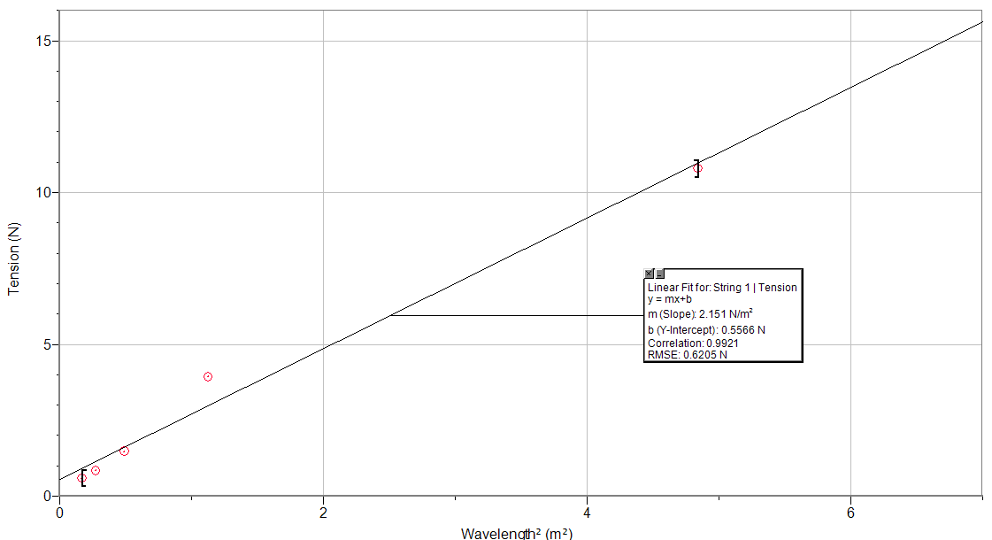

Graph of Tension (N) vs. Wavelength2 (m2) (String 2)

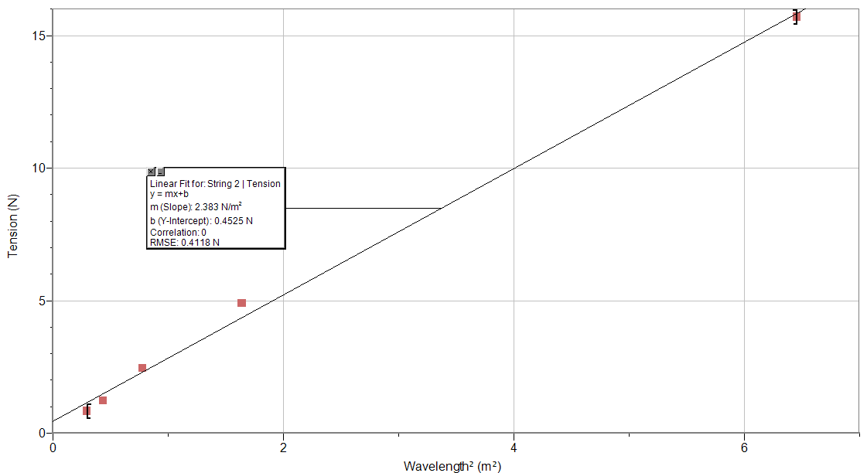

Conclusion

[*What was* learned] From this experiment, we were able to determine the relationship between frequency, tension, wavelength, and speed on a standing wave on a vibrating string. Because of the idea that , with our measured values of wavelength, linear mass density, and tension, we were able to determine both the frequency *and* speed of the wave. [*Uncertainties*] As with almost every experiment, we were only able to replicate a semi-ideal situation. We had no way of eliminating the outside forces of friction and gravity. Both factors play a role in distorting the motion of the string as it vibrates. Friction opposes the motion of the string as it oscillates up and down, and gravity constantly accelerates the string downward. [*First Universal Question*] Given the imperfect scenario, our data was acceptably accurate to the expected results. When our data is plotted, the line of best fit closely resembles the calculated results of an ideal scenario with the same independent variables.

[*Second Universal Question*] The concept of vibrating strings is present among many instruments, namely string instruments. For instance, when you pluck a string on a guitar, that string has a certain linear mass density and tension. Those factors determine the frequency, the speed, and the wavelength of the wave that is created as the string oscillates back and forth to produce the expected sound. Another instance of this idea is present in spider webs. As a spider walks across its web, it produces slight disturbances that create waves along the individual strands of silk. The frequency, wavelength, and speed are determined by the linear mass density and the tension of the strands.

Lab Questions

1. The values we obtained for wavelength are in the Results/Analysis/Physics section.
2. The slope of the graph (Tension divided by wavelength2) is equal to the frequency of vibration of the wave squared times the linear mass density of the string. Using , we found that the frequency for string 1 is 43.630 Hz, which is approximately 27% lower than the frequency of AC 60 Hz. The frequency for string 2: 48.820 Hz, which is approximately 18% lower than the frequency of AC 60 Hz.
3. The speed of the waves can be found using or . Our values for the wave velocity are in the Results/Analysis/Physics section. When the part of the wave rebounding on the pulley is perfectly out of phase with the incident wave, the overlapping of the two waves creates nodes and anti-nodes, which results in the standing wave pattern.

References

1. @ovationpress. "Physics of the Vibrating String." String Visions | from Ovation Press. Ovation Press, Ltd., 16 May 2011. Web. 21 Nov. 2016. <http://stringvisions.ovationpress.com/2011/05/physics-of-the-vibrating-string/>.